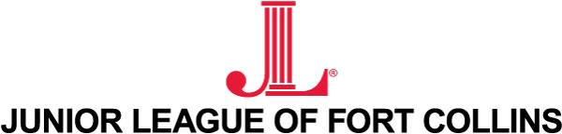
Organizational Development Institute (ODI) Application
Please fill out page 1 and 2 and return to: nominating@jlfortcollins.org
2017-2018 Organizational Development Institute Schedule- Please circle all dates you are available to attend. If available for more than one, please rank them with one being your first preference, two being your second preference, and so on.

Grapevine, TX 11/3 - 11/5/2017
Orlando, FL 2/23 - 2/25/2018
Memphis, TN 4/20 – 4/22/2018
Please fill out the application on the next page.

Please feel free to write a formal letter covering the following questions or write your responses below.
Name:
Date:
How long have you been in Junior League (JLFC and other chapters)?

What positions have you held within our organization?

What JLFC positions are you interested in holding over the next two to three years?

By attending ODI, what knowledge do you hope to gain, and how do you see implementing it to improve our League?

What track are you hoping to attend? Traditional tracks include: Achieving Community Impact, Fund Development, Building Internal Capacity, Governing for Excellence, Membership Development, Marketing and Communications.

